**Goliath Intelligent Agent for Cerner RHO Prerequisites & Installation Guide**

This article was updated to support v12.0.1 of the Goliath Intelligent Agent for Cerner RHO.

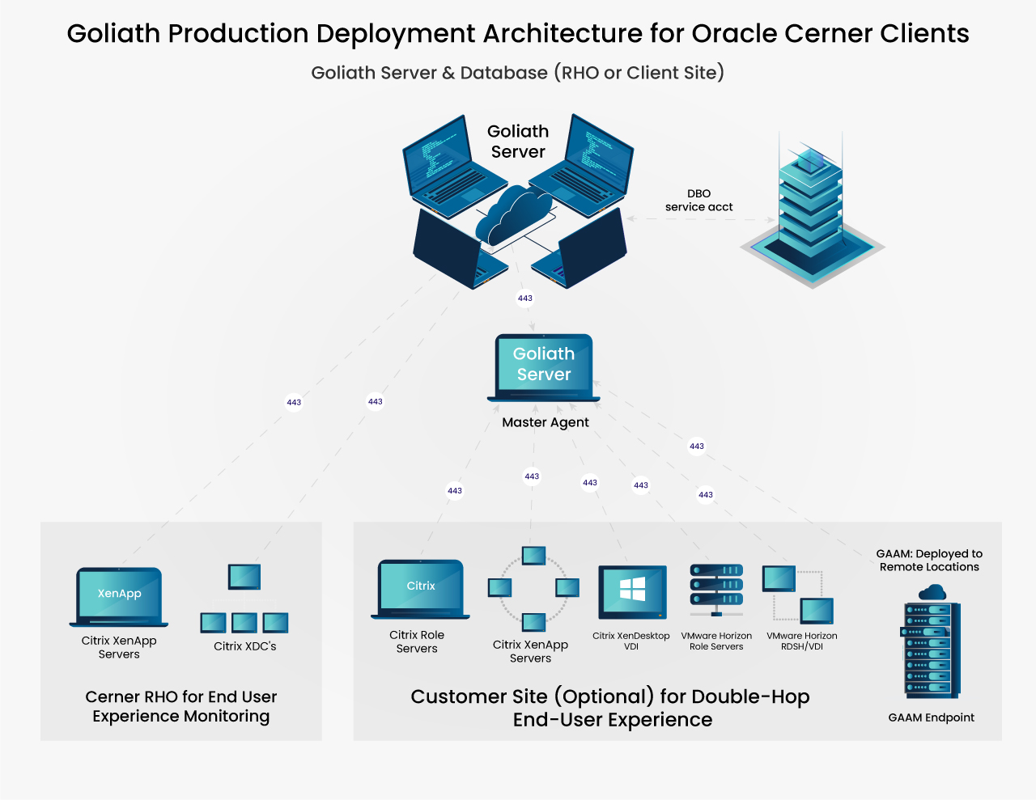

**Article Contents**

* [Goliath Intelligent Agent for Cerner RHO Prerequisites](https://support.goliathtechnologies.com/hc/en-us/articles/360033928494-Goliath-Intelligent-Agent-for-Cerner-RHO-Prerequisites-Installation-Guide-#h_8b2d2849-67f0-48d4-a4f3-fe5e89b09ac4)
* [Goliath Antivirus & Monitoring Solution Exclusions/Filters](https://support.goliathtechnologies.com/hc/en-us/articles/360033928494-Goliath-Intelligent-Agent-for-Cerner-RHO-Prerequisites-Installation-Guide-#h_aeddaa2f-faf3-4182-8f50-c58459dc6657)
* [Are You Ready to Install?](https://support.goliathtechnologies.com/hc/en-us/articles/360033928494-Goliath-Intelligent-Agent-for-Cerner-RHO-Prerequisites-Installation-Guide-#h_1f7b9d2f-7a11-4ac8-a927-3cfd2426fee7)
* [Installing the Goliath Intelligent Agent for Cerner RHO](https://support.goliathtechnologies.com/hc/en-us/articles/360033928494-Goliath-Intelligent-Agent-for-Cerner-RHO-Prerequisites-Installation-Guide-#h_d17bb799-47fc-42e6-ae01-ab4cdae621d4)

**Goliath Intelligent Agent for Cerner RHO Prerequisites**

**Firewall**

* HTTPS 443* opened outbound from the agent location to the Goliath Server for agent connectivity

* Default ports listed and can be modified.

**Citrix Virtual Apps and Desktops Monitoring**

* Versions 7.6 to 2209 supported
  + Windows 8-10 (Desktop), 2012 R2 – 2022 (Server)
* Service Account with the following privileges is required for Inventory & Metric Collection:
  + Read-Only Admin within Citrix Studio
  + Windows Administrator on the Delivery Controller
    - requires permission to run a windows service
  + If using Citrix PVS, the service account must also be a member of the PVS Farm Administrator group and have Windows Admin Rights on the Provisioning Servers, also to run a service.
* Citrix OData 3.0 ([Check your OData version](https://support.goliathtechnologies.com/hc/en-us/articles/4405942977687))
* Citrix Profile Management service is required to be installed and running on the VDA in order to collect Logon Duration metrics.
  + Citrix Profile Manager needs to be installed on the VDA and the service needs to be started even if you are not using User profile Management for managing user profiles.
* PowerShell 3.0 or newer required on the Delivery Controllers and VDAs
* Full Microsoft SQL Server suggested for full implementations of Goliath Performance Monitor
* Support for real-time process metrics can be resource intensive requiring us to determine viability that we would test in the implementation.

**Agent Specifications**

* Virtual Machine or Physical Server
  + Windows Server 2012 R2 - 2022
    - Goliath version 11.8.0 and newer
  + Windows 8 - 10
  + Unix/Linux & Mac up to kernel version 5.1x
* Goliath Agent Performance Specs
  + Avg <=2% CPU
    - An additional 2-3% can be added depending on Citrix/Horizon user density by native collection tools e.g., WMI
  + 40 MB on Disk
  + ~ 150 MB RAM
* Citrix DDC agent version 11.8.3.2 must be used for versions of Citrix OData 1.0 and 2.0

**Supported Languages**

Goliath Technologies supports user experience monitoring for the following Citrix Virtual Apps & Desktops**:**

* Windows installation English OS, Spanish OS (Unicode not supported)
  + Spanish language pack on English OS supported
* Windows installation of German and French
  + Support for Session details and ICA Latency metrics
  + Partial support for Logon Duration metrics
  + No language pack support

**Goliath Antivirus & Monitoring Solution Exclusions/Filters**

While not a-typical, we have been exposed to client environments which require antivirus filtering, or exclusion rules needing implemented due to the antivirus software conflicting with the Goliath Intelligent Agent. For that reasoning, we do recommend implementing exclusion rules which consist of the following:

**Machines with the Goliath Cerner Agent on them (Citrix machines, DDC, etc)**

* Directory Exclusions:
  + Paths: “\Program Files\MonitorIT” & “C:\Users\All Users\Goliath”
    - Ensure recursive exclusions for the subfolders is allowed
* Process Exclusions:
  + RPMAgent.exe – This is the process which is launched by the Agent’s Service
  + AgentService.exe – Process supporting the Agent’s Windows Service

**Are You Ready to Install?**

To complete the installation of the Goliath Intelligent Agent for Cerner, please ensure you have the following items available and prepared:

1. Agent port that will be used for communication back to the customer’s Goliath Server
   1. Default port is 443
2. Customer’s Goliath Server IP Address/FQDN that will be used for agent communication
3. Goliath Intelligent Agent for Cerner RHO Installation File
   1. Please note, the Goliath Intelligent Agent for Cerner RHO is the same as our standard Goliath Intelligent Agent.
4. Additional prerequisites listed above are completed

**Installing the Goliath Intelligent Agent for Cerner RHO**

The Goliath Performance Monitoring solution for joint customers (i.e. Universal Health Services (UHS), North Bay) requires product components deployed in both the customer’s environment (Server, DB, VMA, local agent, master agents) and Cerner RHO (agents).

The **Intelligent Agent for Cerner RHO** is required to be **installed** on the **Citrix Delivery Controller** (XDC) and each **Session Host/XenApp Server** for the specific customer farm.

It is known that Cerner previously developed and maintained a logon script that installs the Goliath agent each time a Cerner machine is deployed (i.e. Universal Health Services (UHS) deployment). The agent is also Gold/Master Image ready and can be installed directly into the image.

Citrix Delivery Controller (XDC) Installation:

* (Recommended) [Agent Installation/Update via Installer](https://support.goliathtechnologies.com/hc/en-us/articles/360025959993)
* [Agent Installation/Update via Command Line](https://support.goliathtechnologies.com/hc/en-us/articles/360025008894)
* [Silent Agent Installation/Update](https://support.goliathtechnologies.com/hc/en-us/articles/360025012374)

Citrix XenApp Server Installation:

* (Recommended) [Agent Installation/Update for Gold Images, Master Images, & Templates](https://support.goliathtechnologies.com/hc/en-us/articles/360025009874)
* [Agent Installation/Update via Command Line](https://support.goliathtechnologies.com/hc/en-us/articles/360025008894)
* [Silent Agent Installation/Update](https://support.goliathtechnologies.com/hc/en-us/articles/360025012374)